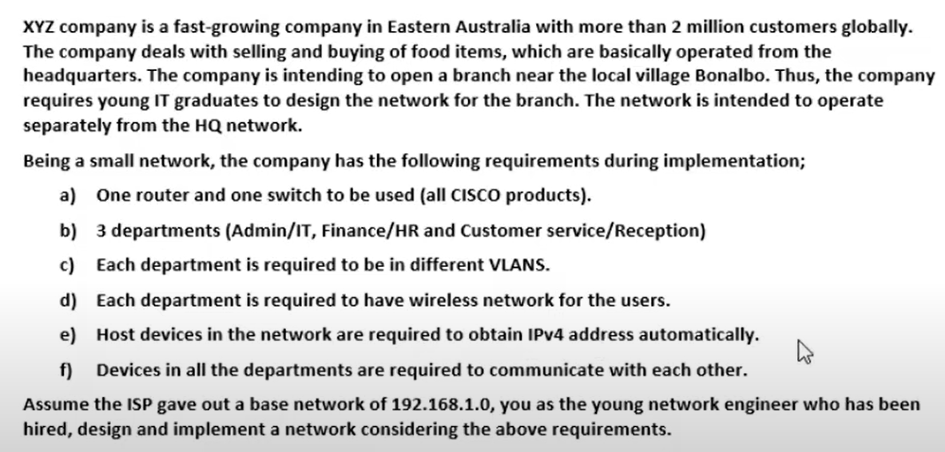

Base Network: 192.168.1.0  
No. of subnets: 3  
No. of subnets: 2^n  
2^n=3 🡺 n=2

Class C= 255.255.255.0 🡺 11111111.11111111.11111111.00000000  
Borrowing 2 bits  
New Binary 🡺 11111111.11111111.11111111.11000000  
New Subnet Mask: 255.255.255.192  
Block size: 64

1st Subnet  
 Network ID: 192.168.1.0  
 Broadcast ID: 192.168.1.63  
 Usable IP Range: 192.168.1.1 - 192.168.1.62

2nd Subnet  
 Network ID: 192.168.1.64  
 Broadcast ID: 192.168.1.127  
 Usable IP Range: 192.168.1.65 - 192.168.1.126

3rd Subnet  
 Network ID: 192.168.1.128  
 Broadcast ID: 192.168.1.191  
 Usable IP Range: 192.168.1.129 - 192.168.1.190